Install Document Template
CipherRobot App
(Implementation of encryption and decryption)

Created By : Gajanan Gaikwad
Contact : +37120360109/ +917709635664
Email : gajanangaikwad999@gmail.com

Table of Contents
1 Introduction 3
2 Installation Manual 3
2.1 Pre-requisites 3
2.2 Installation Procedure 3
2.3 Technical Tests 11

Introduction
There are two application which we have to install
- Spring boot Application (CipherRobot) - Backend
- Angular Front end application (CipherRobotUI) – Front end
Github Urls:
https://github.com/gajanan999/CipherRobot.git -- Spring boot Backend application
https://github.com/gajanan999/CipherRobotUI.git -- Angular Front end application

In Spring boot application I have added following functionality
- REST API
URLS:
Create User : http://localhost:8080/api/createUser
Login : http://localhost:8080/api/login
GetDataEntities: http://localhost:8080/api/getData
To Encrypt the text: http://localhost:8080/api/getEncryption
TO Decrypt the Text: http://localhost:8080/api/getDecryption
- Spring AOP – For logging purpose
- Implementation of Hibernate using JPA CRUD repository
- In-Memory database – h2-database
TO access the console of the database you can try
http://localhost:8080/h2-console
username : admin
password : password
JDBC URL: jdbc:h2:mem:testdb

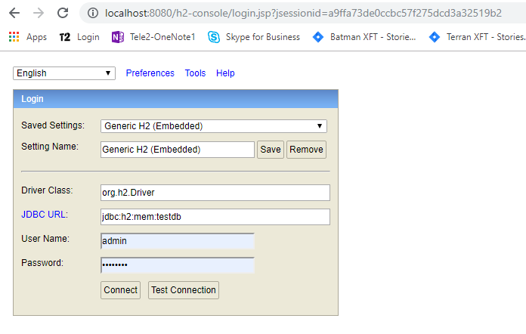
- Spring Dependency Injection using Autowire and IOC
- Implementation of AES algorithm for 128 bit key
- Implementation of DES algorithm
- Implementation of factory design pattern
- Implementation of @DataJpaTest

Installation Manual
In order to install these two application you will need some pre-requisites and tools,

Pre-requisites
You will need Node and Java 8 installed on your machine to run these applications
For NPM : https://nodejs.org/en/
For Java : https://www.oracle.com/technetwork/java/javase/downloads/jdk8-downloads-2133151.html

Tools:
- Apache Maven
- Spring Tool Suite / Eclipse
- Visual Studio Code
- Github (Git Bash)

Installation Procedure
First of all we will install the spring boot application.

Spring boot application installation
As we are using in-memory database (h2-database) so we will not need to install and database server
Lets install the spring boot application,
- Go to the Github
https://github.com/gajanan999/CipherRobot
- click on clone & download button and copy the URL
https://github.com/gajanan999/CipherRobot.git
- Then open the workspace ( any folder on the disk )
- open Git Bash there
type the command : $ git clone https://github.com/gajanan999/CipherRobot.git
- Then the project will be clone into your disk folder
- Now, Open the STS/Eclipse (Follow the procedure to import the maven project if you already know it )
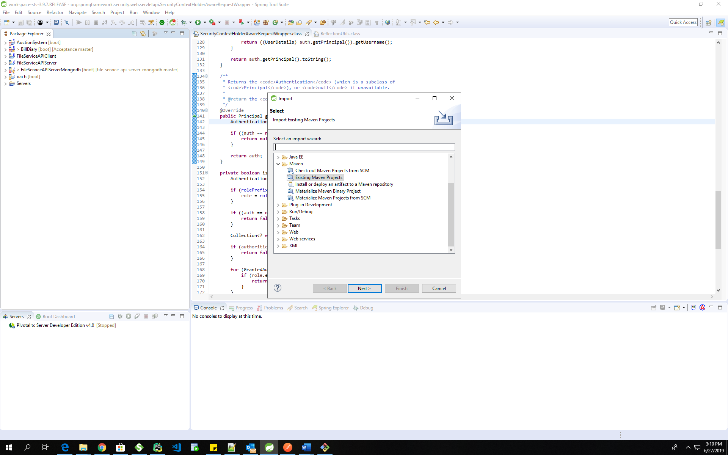

Click on the existing maven project and select the project from the folder in which we have cloned our github project CipherRobot.

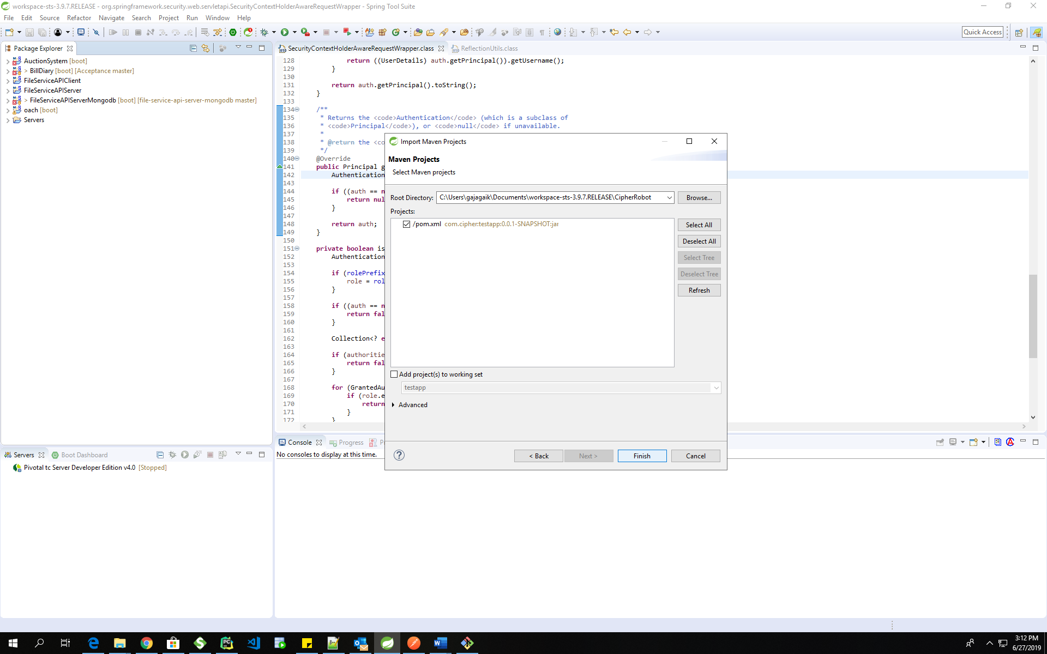

- Click on finish project will be get imported in STS/Eclipse.

- Now We can open the project and run it as maven build
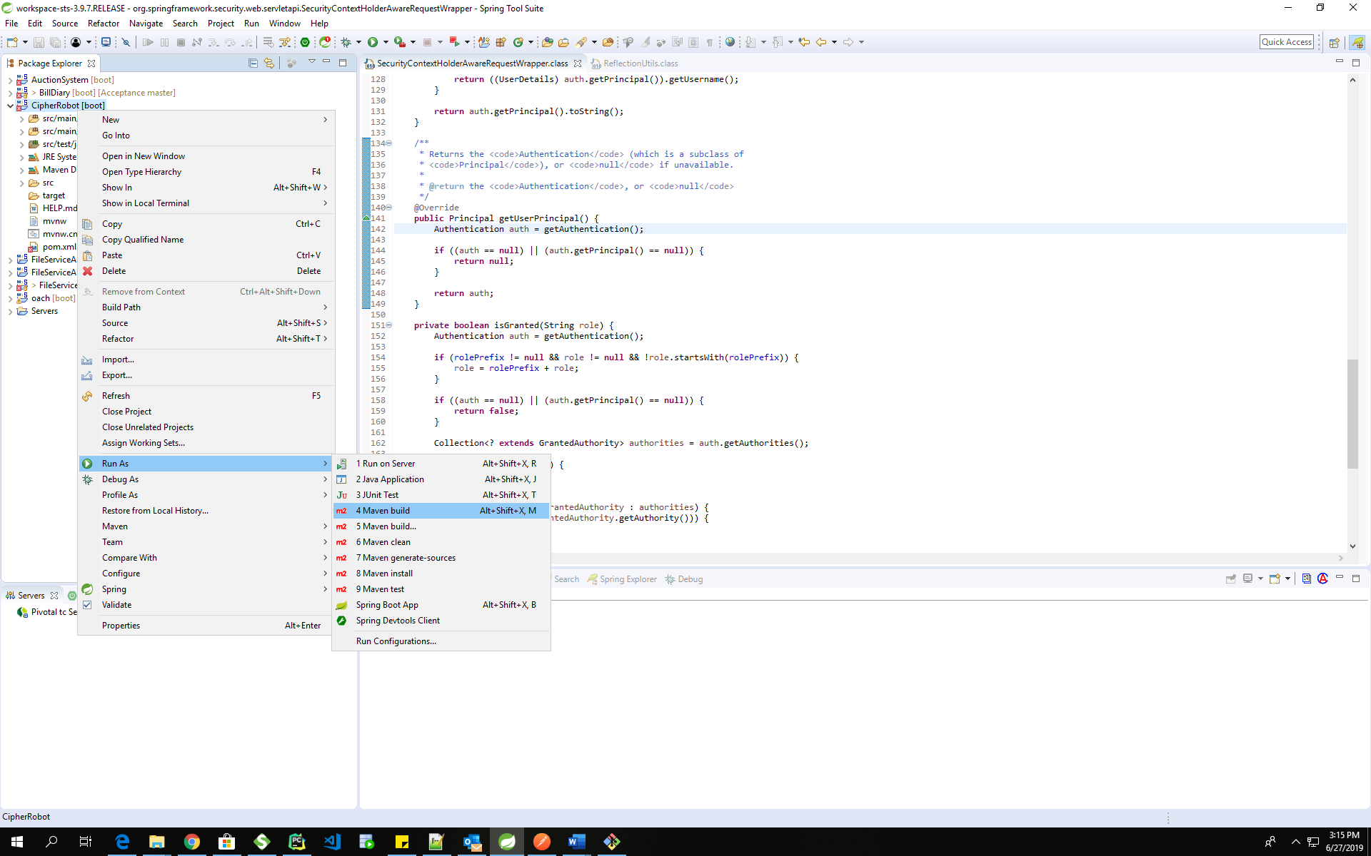

- It will open the new window there you have to specify
Goal: clean package

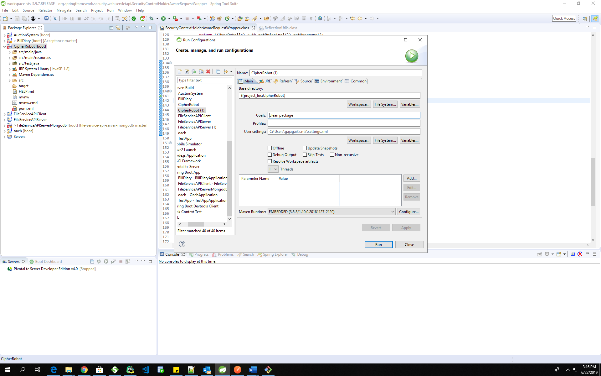

- And After setting the goal run the project
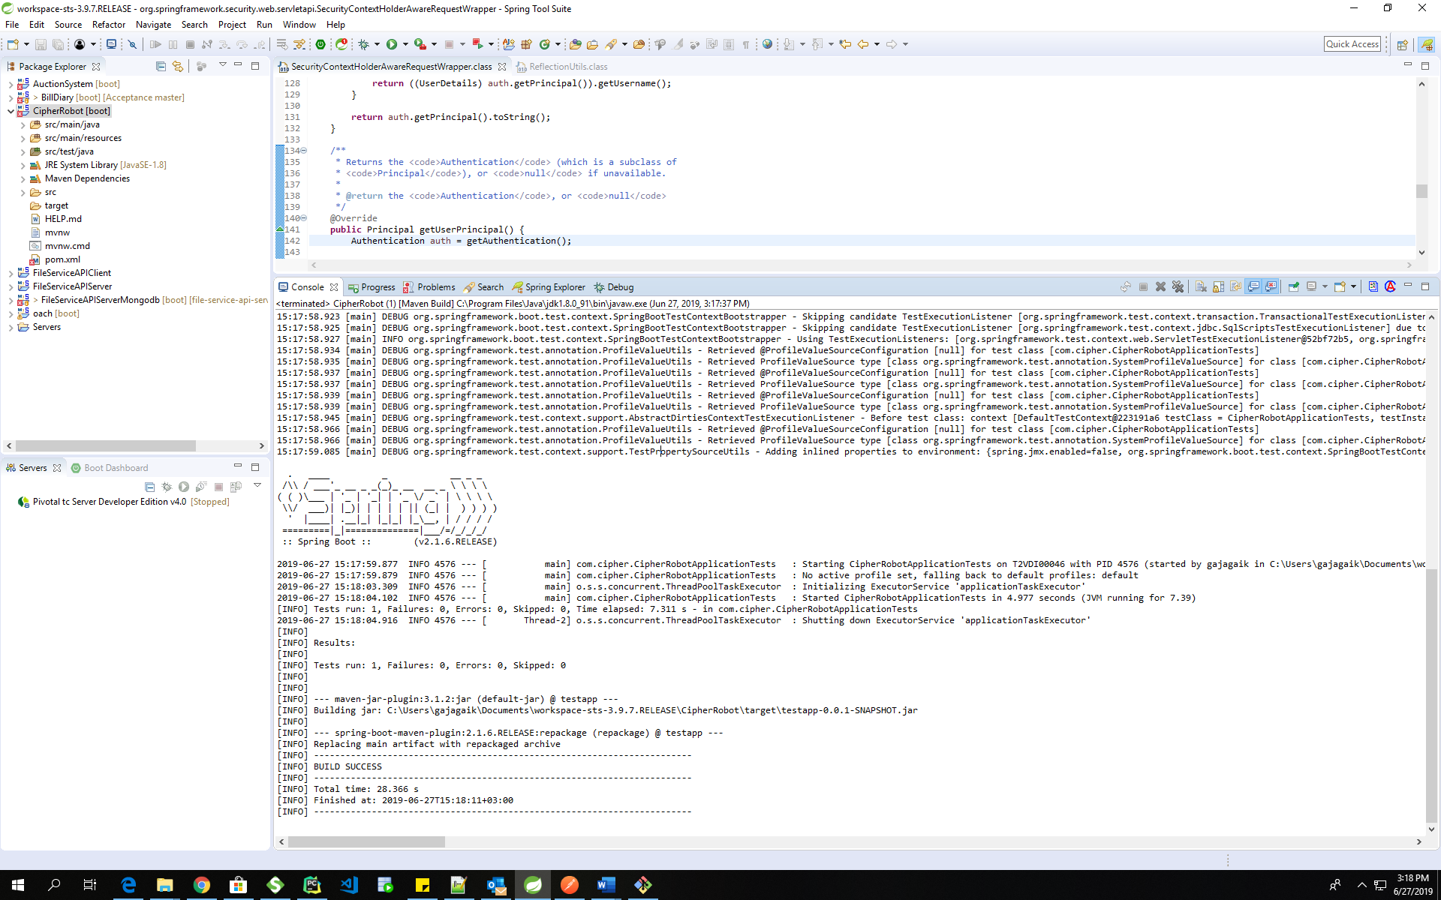

- It will give you the result as BUILD SUCCESS
- Now Run the project as Spring boot application
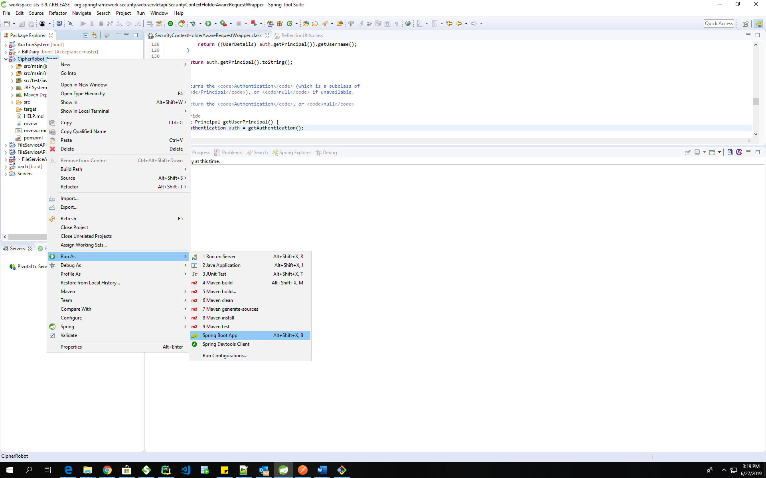

- Spring Boot application server (Embedded tomcat server) will be starting on 8080 port, if it is not starting the please change the port no in application.properties.

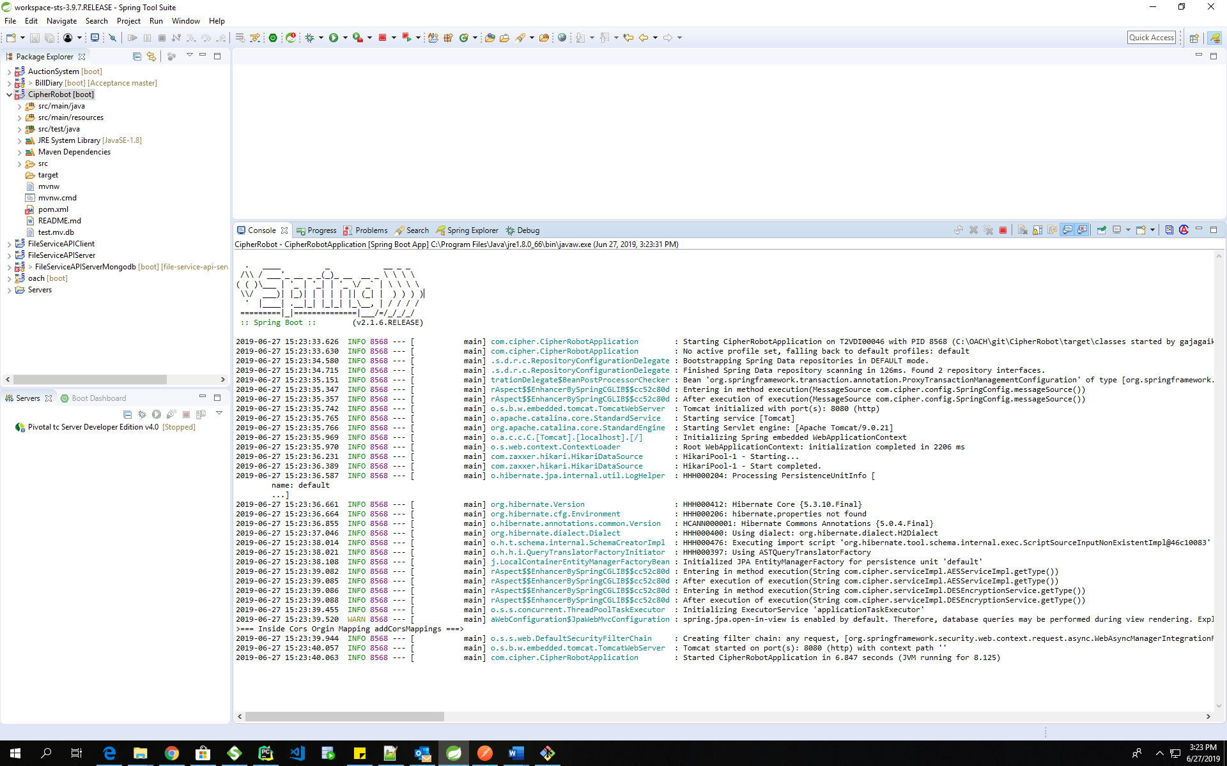

As you can see in the screenshot the server is started.

Angular Application Installation

Now lets start the front end application (Angular application),

- Go to the Following URL
https://github.com/gajanan999/CipherRobotUI

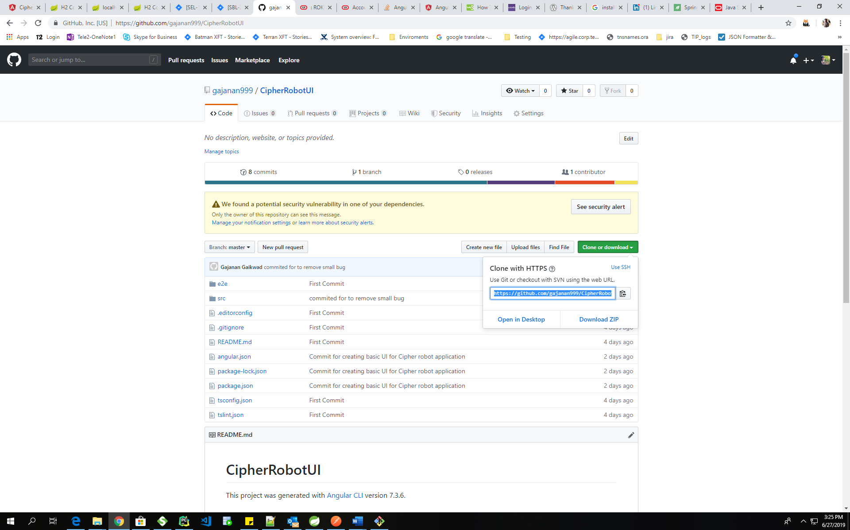
- Copy the Clone URL
- Open the Gitbash and go the the Folder path we we have choose for spring boot app
- Now run the following command
$ git clone https://github.com/gajanan999/CipherRobotUI.git
- It will clone angular application in to the folder
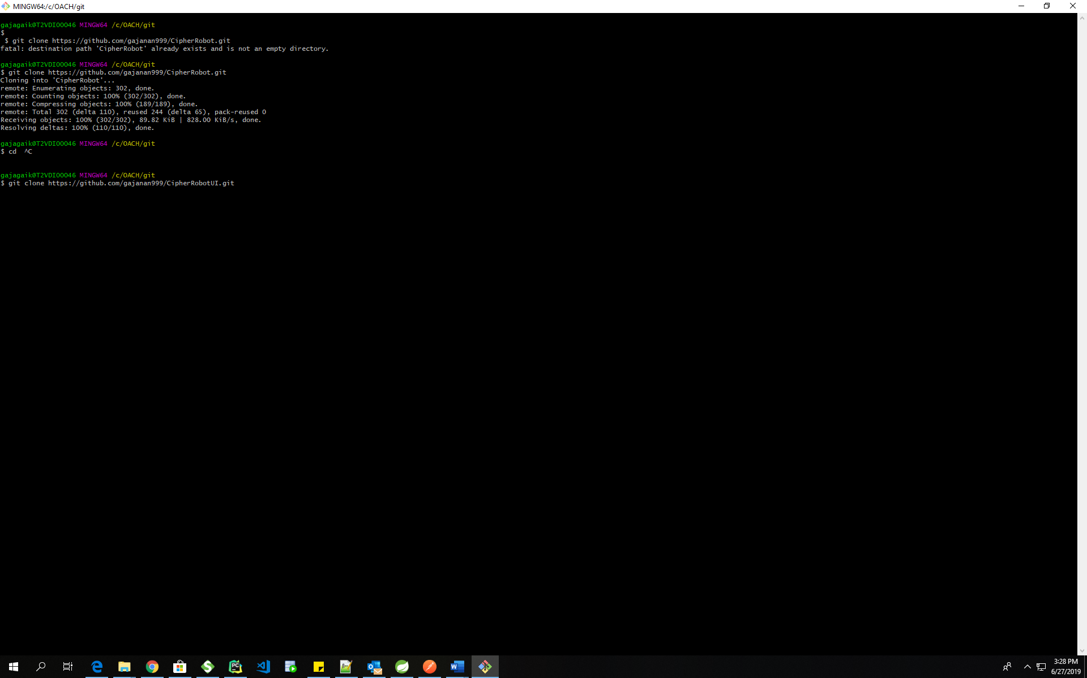

- Install @angular-devkit/build-angular
Use following command
$ npm install --save-dev @angular-devkit/build-angular
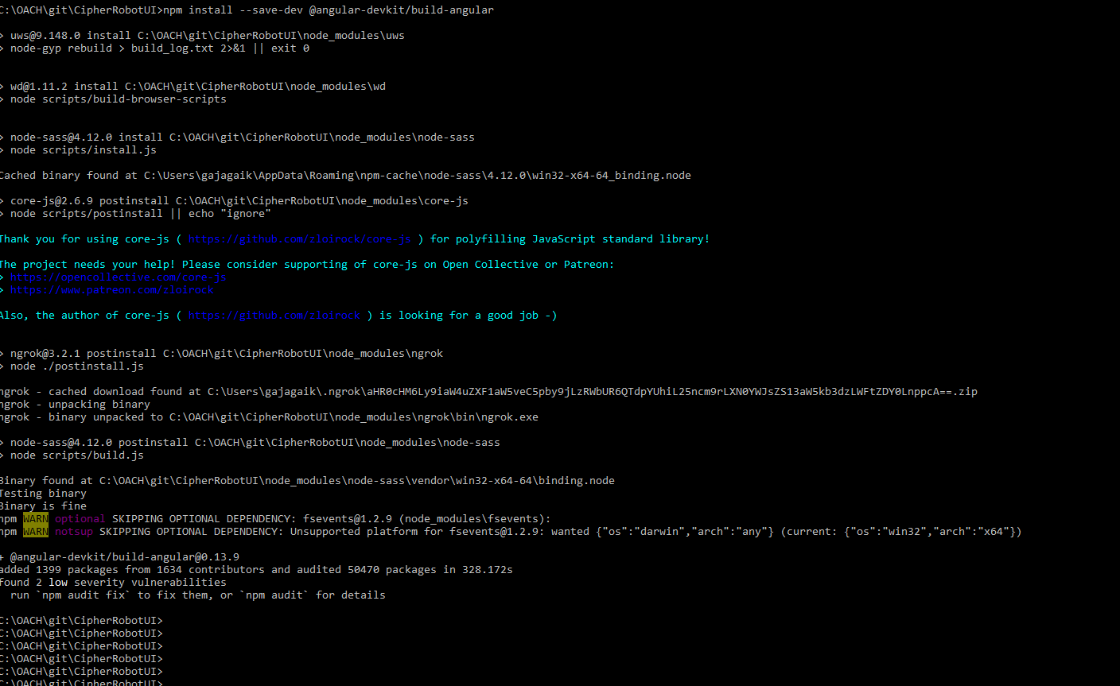

- Now open the Command line and go to the folder path
And the run the following command
$ ng serve

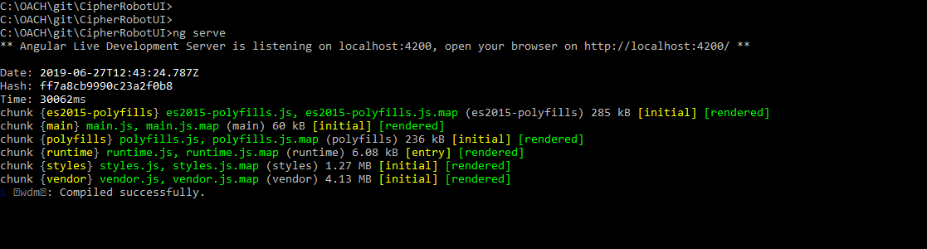

- Now open the login page of the application
http://localhost:4200/login

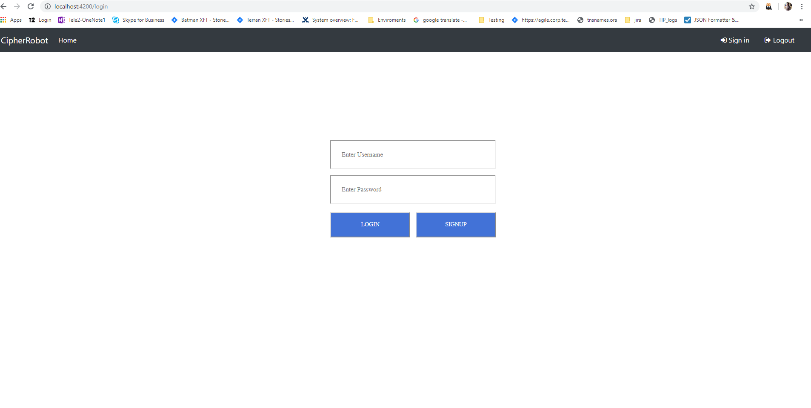

- Now click on signup and fill the information, As we are using in memory database so every time we start spring boot application we have to signup with user

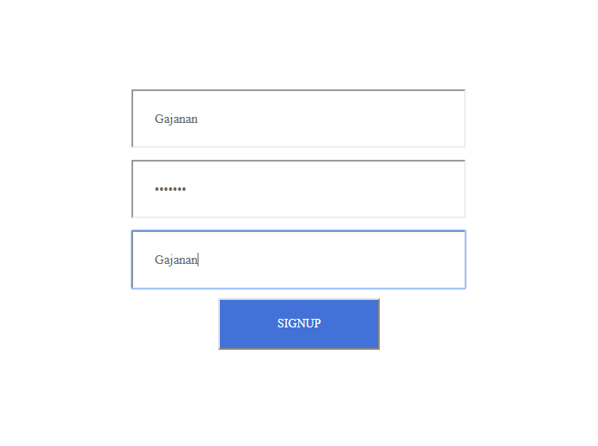
- After sign up you will redirected to the login page
- User your credentials and login into the system

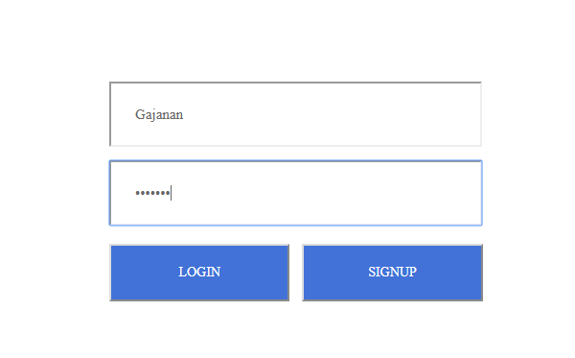

- After successful login you will be redirected to the main page of application

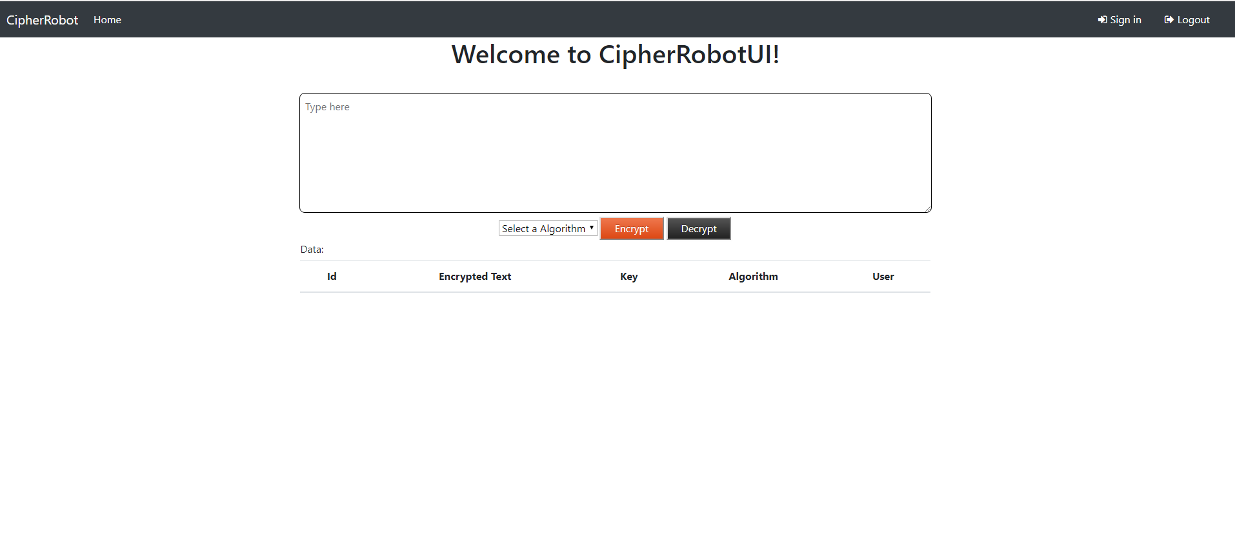

Technical Tests

Here you can test the application by
TEST 1 : Encrypt Text Steps
- Insert any word in the text box
- Then select the algorithm by which you wants to encrypt the data
- And then click on the encrypt button

Expected Result:
One row should be added in the follwing data table with encrypted text and also the input box should be replace by encrypted text.
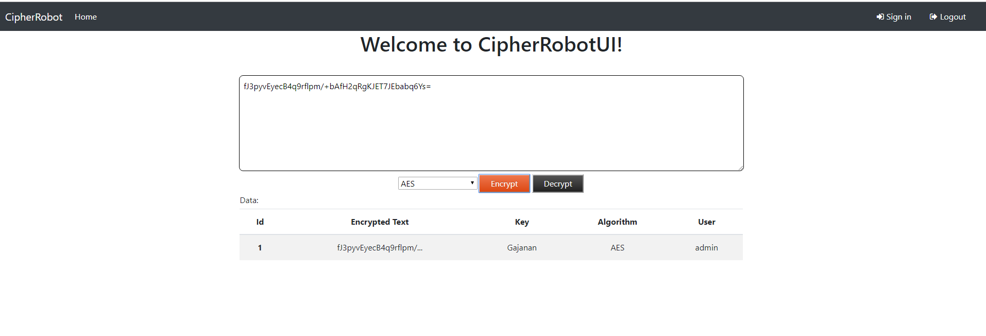

TEST2 : Decrypt text Steps
- Select the row
- Then select the algorithm by which you have encrypted the text
- And then select the decrypt button

Expected Result:
The encrypted text should be get decrypted and shown on the screen
As you can see in the screenshot.
